

SmartSelect Decision Support Tool

Job Aide

October 2022



Overview

This document provides you with background and details on how to use SmartSelect. It includes how to navigate the tool, how to interpret results and customize and modify scenarios so you can estimate the potential costs for each of your Trinity Health-sponsored medical plan options.

The results are based on assumptions and should be used for informational purposes only. Trinity Health is not providing any advice nor any guarantee of health care benefits or out-of-pocket costs. Numerous factors will affect your health care decisions and your actual health care usage and costs may be different from the levels used to calculate your results. The results should not be used as a substitute for obtaining medical or financial/tax advice. **You are not expected to enroll based on these results as plan selection is ultimately your decision.**

Getting Started

By selecting Start Exploring!, you will be asked a series of questions regarding you and your family members anticipated health care usage.  Answer each question to see which Trinity Health-sponsored medical plan is projected to cost you the least based on standard assumptions.

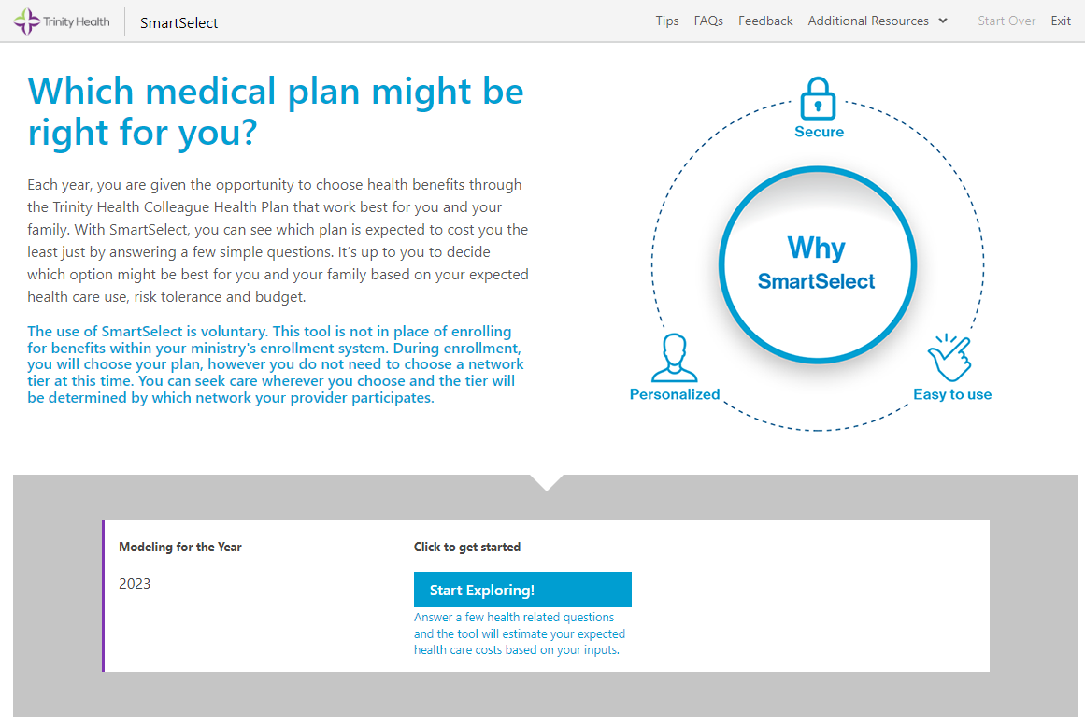

Understanding the Results Page

The plan with the lowest expected cost (based on your answers) is highlighted in light green, which in most cases, will be Tier 1 providers. If your family primarily utilizes Tier 2 providers, please take those numbers into consideration when analyzing your results.

* The bars in the chart show the breakdown of out-of-pocket costs versus the payroll contributions for each plan.
* The bars are separated into Tier 1 providers and Tier 2 providers. Although you do not need to select which tier you will utilize when enrolling in benefits, it is important information to understand when making your health plan decision.
* To see plan design details, click on the name of each plan under the graph.

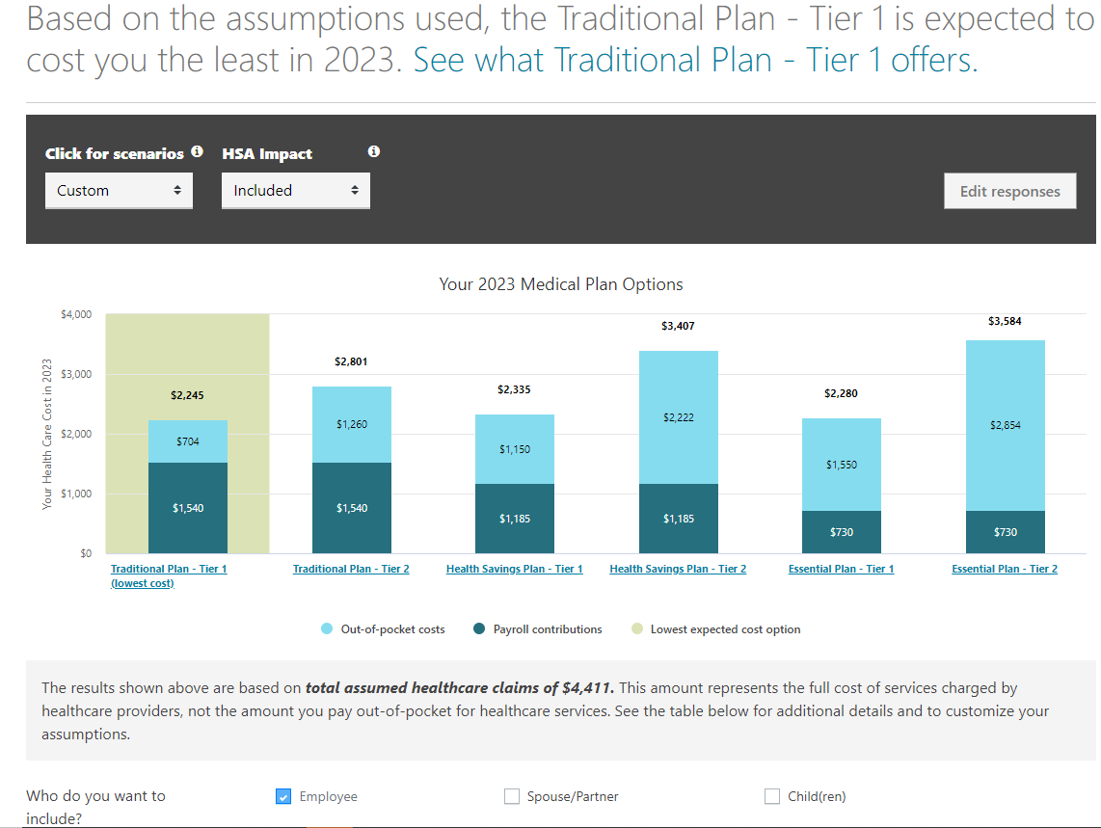

**HSA Impact**

Allows you to see how your costs change if you use the Health Savings Account (HSA) contribution provided by Trinity Health to offset your out-of-pocket health care costs. If you enroll in the Health Savings Plan you will receive $650/$1,300 (employee only/all other coverage levels) in your HSA at the start of the year to help pay for eligible health care expenses.

**Scenarios**

Allows you to see your results under various scenarios:

**Your Responses** – Shows the initial lowest cost option based on your responses to your questions.

**Low Claim** – Models what your costs may be if you have minimal health care needs. For example, what if you only had preventive services throughout the year.

**High Claims** – Models how costs would change if you have major health care expenses that cause you to reach each plan’s out-of-pocket maximums (assumes in-network only).

Customizing and Changing Detailed Assumptions

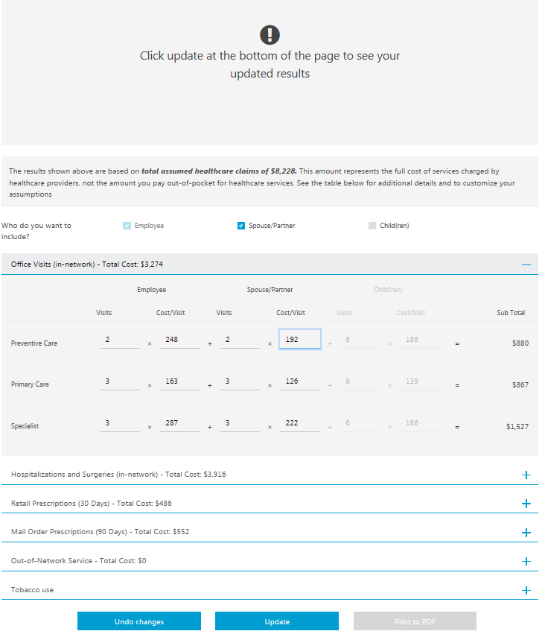Under the chart on the right side of the page, select “+” or “-” to expand/contract each category. The frequency of visits and the cost per visit are populated based on national averages and your answers to the questions.

* Change any of the assumptions in the table, including frequency of visits or costs.
* Once you’ve finished customizing, click **“Update”** to see an updated result in the graph above based on the new assumptions.
* You can also choose to include or exclude your spouse/partner or child(ren).

**UNDO CHANGES:** Allows you to undo your changes since the last time you updated.

**UPDATE:** See an updated result based on your new assumptions.

**PRINT TO PDF:** Print to a PDF so you can save to your computer.

**Important Note:** Cost is not the only factor when it comes to making a medical plan decision. For example, you should consider your anticipated health care needs, the anticipated network of providers you will use and your overall risk tolerance.